General Info

ERDPRO - Torque, Drag and Hydraulics Model
C:\Users\HXR ERD\Desktop\New Bid Quotes\Frontier Deepwater\UltraDeepwater Example.EP2

 | Date | 12/13/2018 | Legal
 | Operator |  | Contractor
 | Well name |  | Type of job
 | Location |  | Prepared by
 | Comments | 8.5" Drilling - UltraDeepwater

Speed | 600 | 300 | 200 | 100 | 6 | 3
Reading | 98.0 | 78.0 | 65.0 | 52.0 | 14.0 | 12.0
Rheology model: HB
n = 0.41 K = 6.199 (lbf-s^n/100ft2) Yield stress = 0.0 (lbf/100ft2)
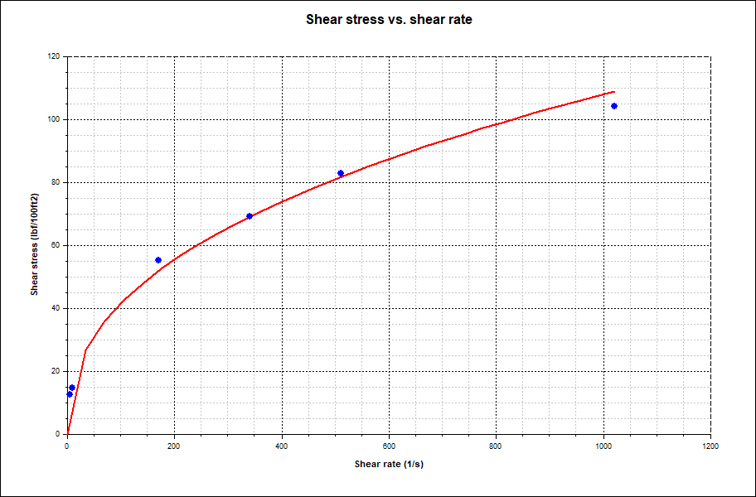

0.0 0.00 0.00 0.0 0.0 0.0 0.0 0.0 0.00
6500.0 0.00 0.00 6500.0 0.0 0.0 0.0 0.0 0.00
8500.0 20.00 0.00 8459.6 345.5 345.5 345.5 0.0 1.00
11736.0 20.00 0.00 11500.5 1452.3 1452.3 1452.3 0.0 0.00
22378.0 20.00 0.00 21500.7 5092.1 5092.1 5 092.1 0.0 0.00
24378.0 43.00 0.00 23194.5 6130.1 6130.1 6130.1 0.0 1.15
35000.0 43.00 0.00 30963.0 13374.3 13374.3 13374.3 0.0 0.00
38333.0 43.00 0.00 33400.6 15647.4 15647.4 15647.4 0.0 0.00

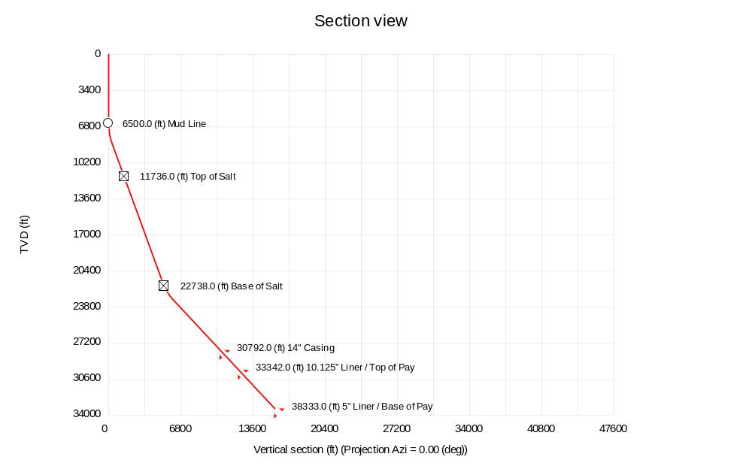

14” Casing

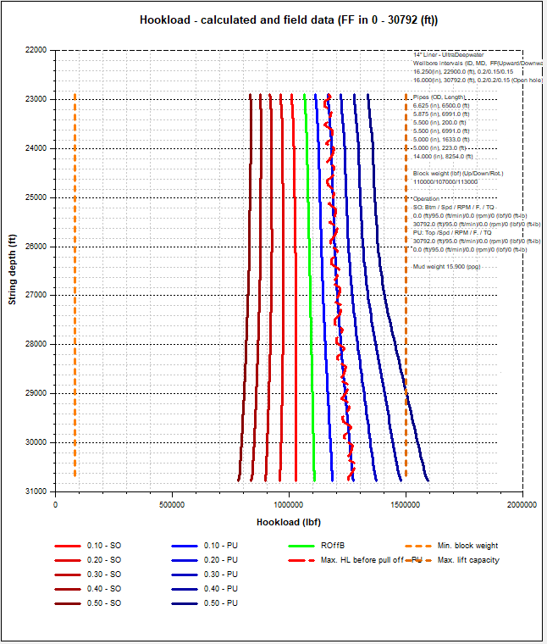

This is what we call a “one-way” trip - by the numbers, unless P/U FF is very low, Pipe can’t TOOH
Possible to set 18” deeper?
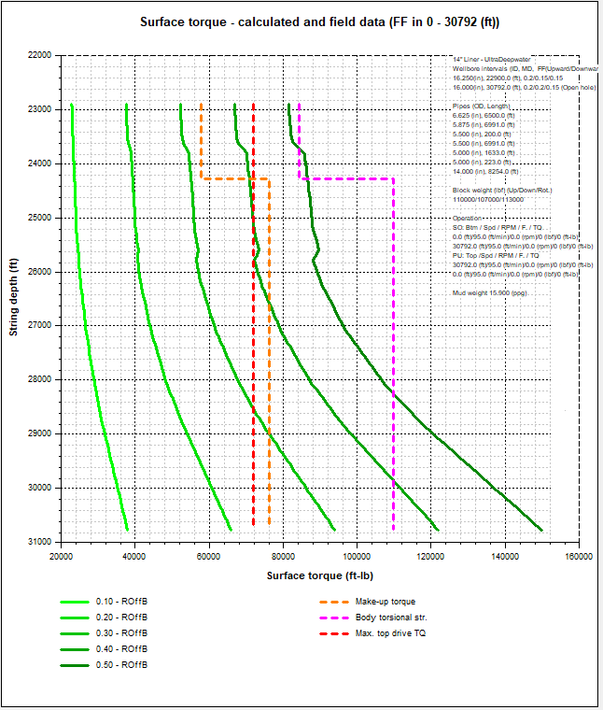

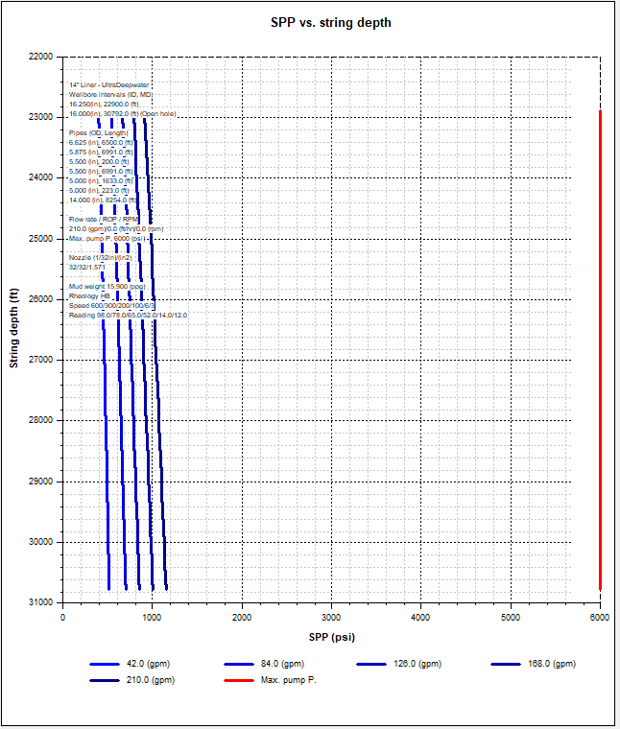

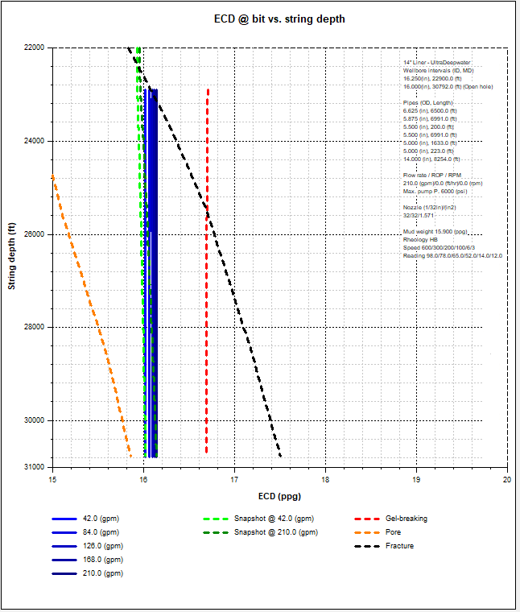

Very Low Circulation Rates required. Expect losses during cementing; consider two-stage

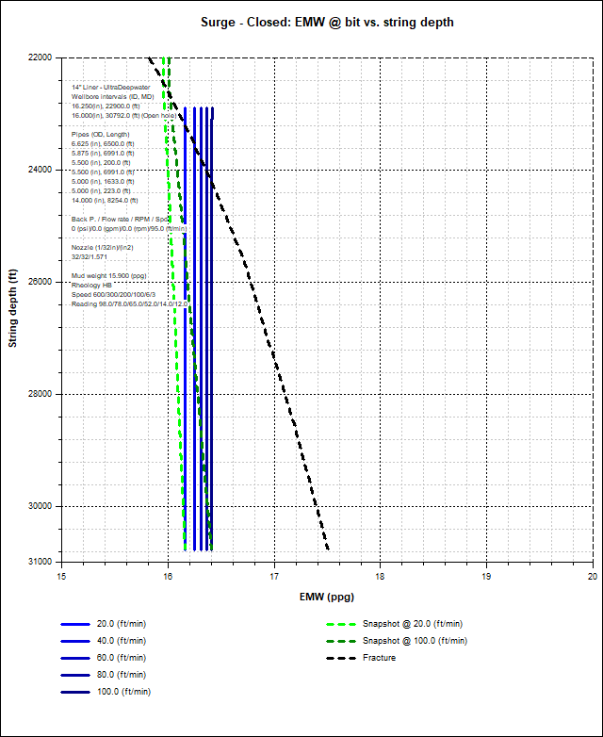

Consider thin mud back a bit or set 18” deeper? No major issue
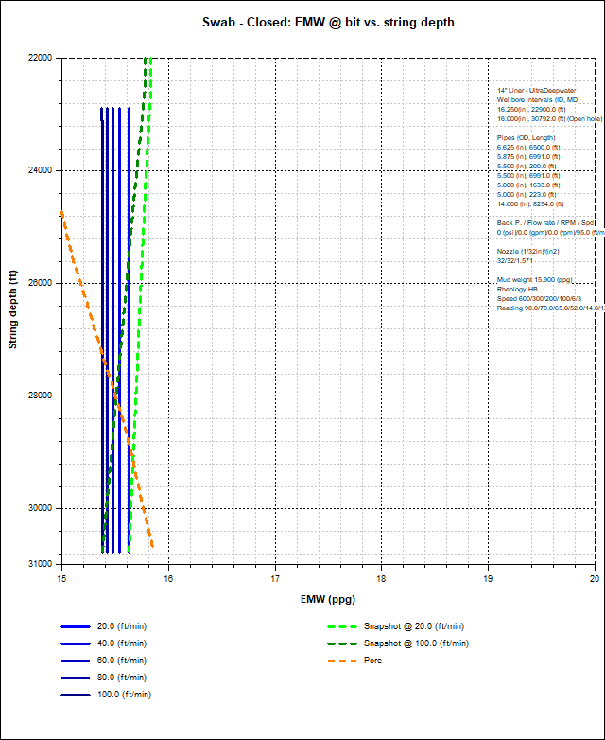

Pumps need to be idled to work pipe IF it will work
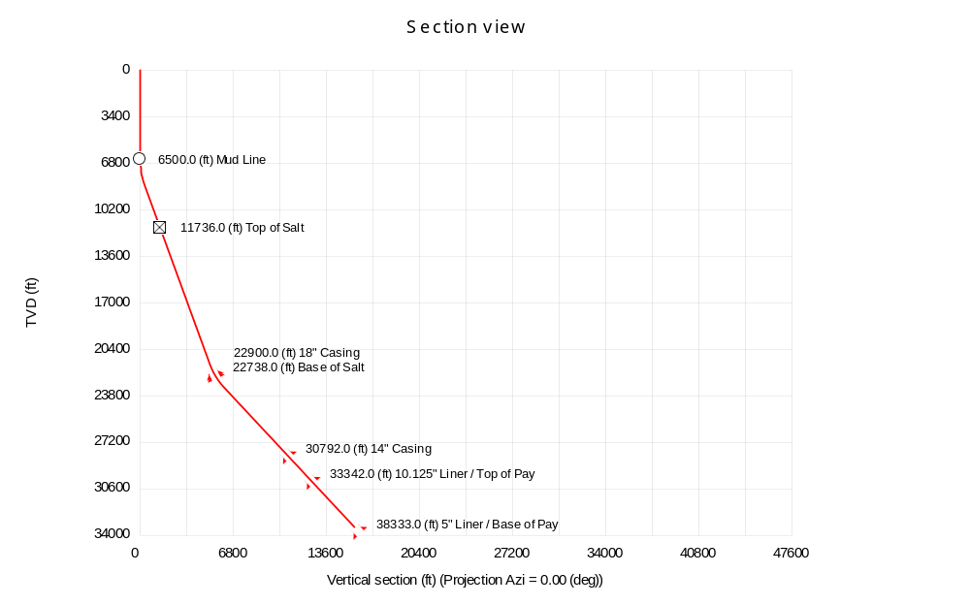
Long 18” Section to cover Salt; need to verify tensile on new V pipe

10.125” Liner

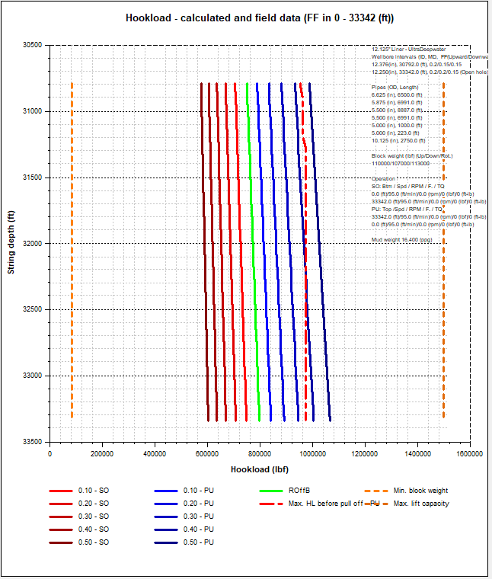

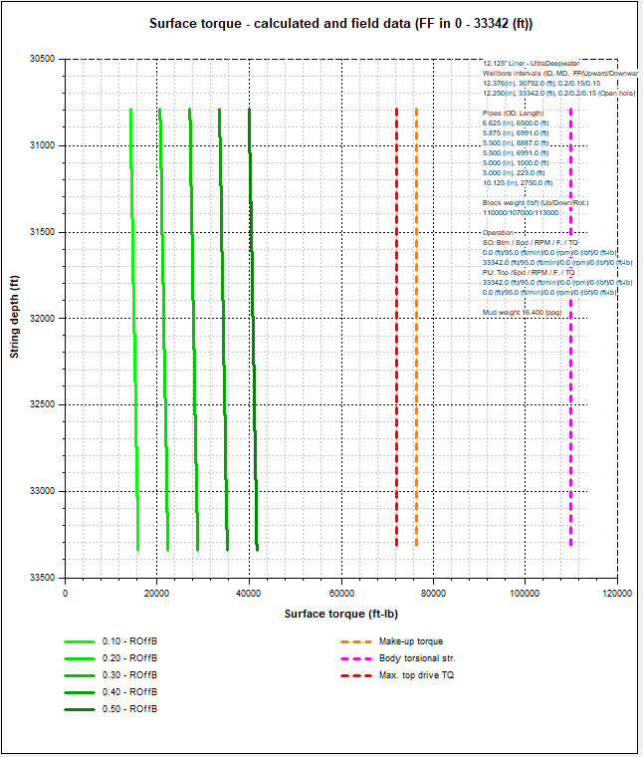

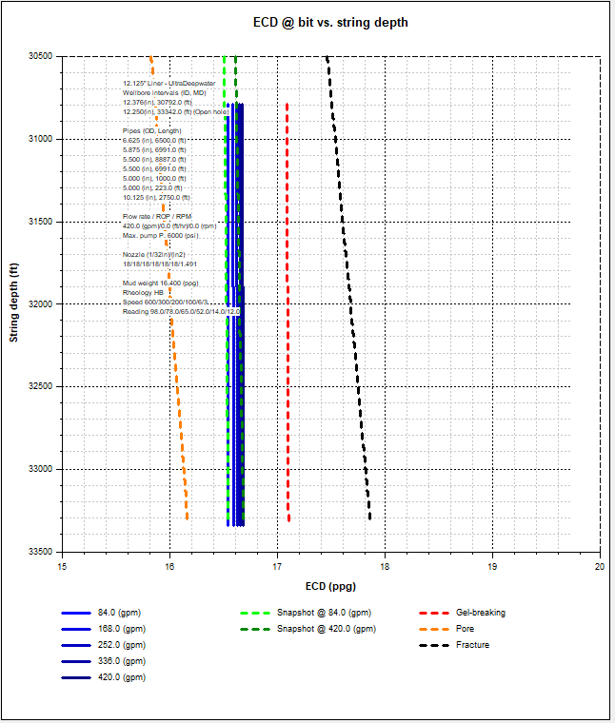

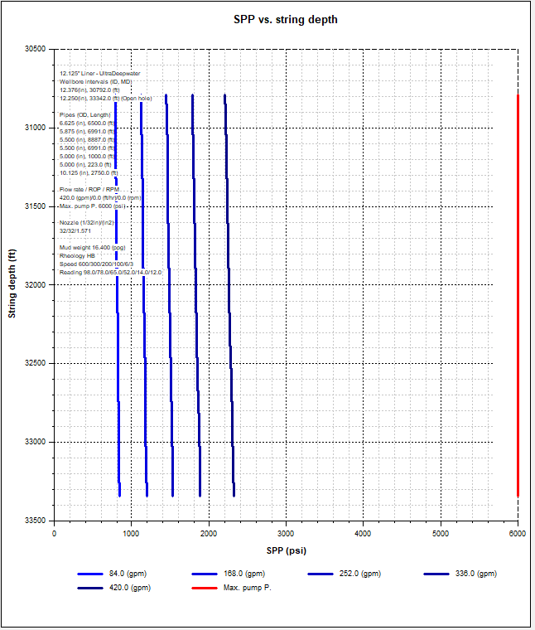

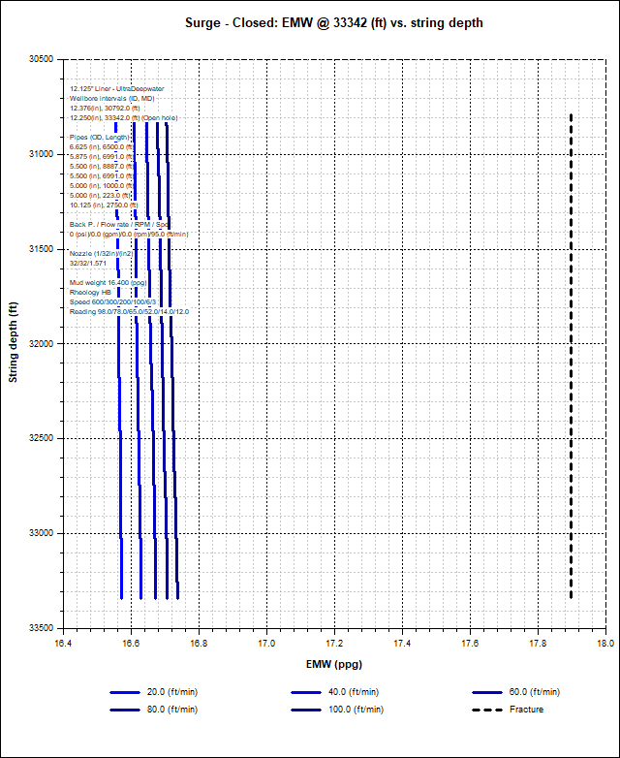

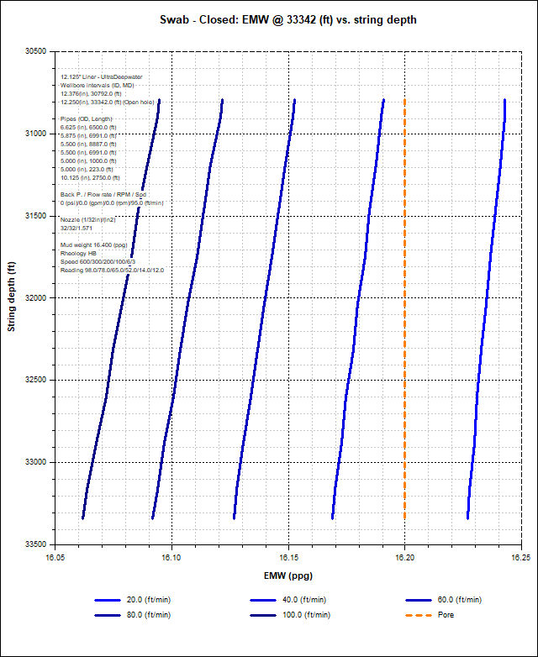

8.5” Drilling Section

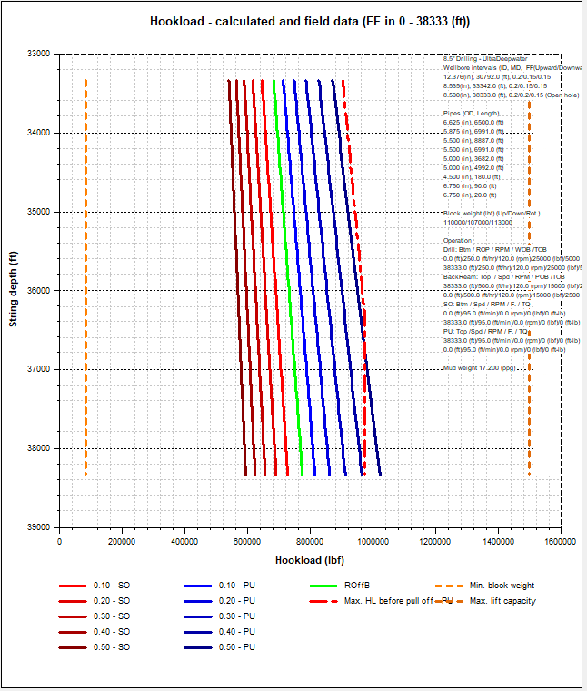

New S135 used for all sections; V has higher rating

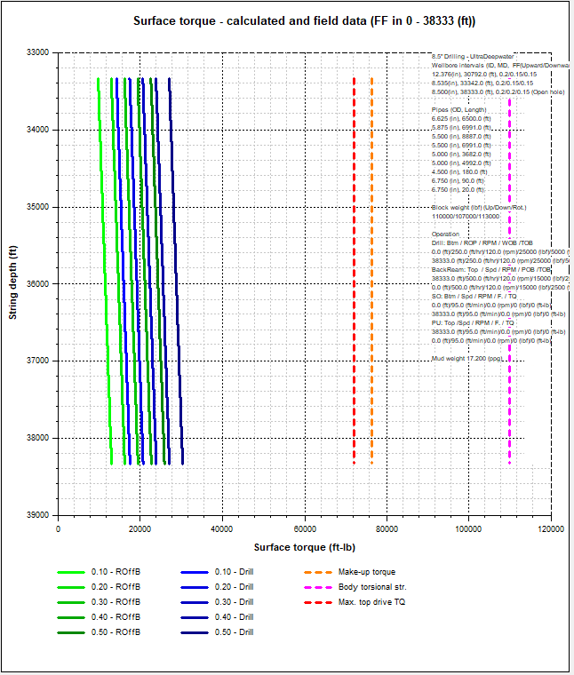

With heavy use of NRDPP’s: .10 FF / 20% Drag Reduction over section; Rollers possible

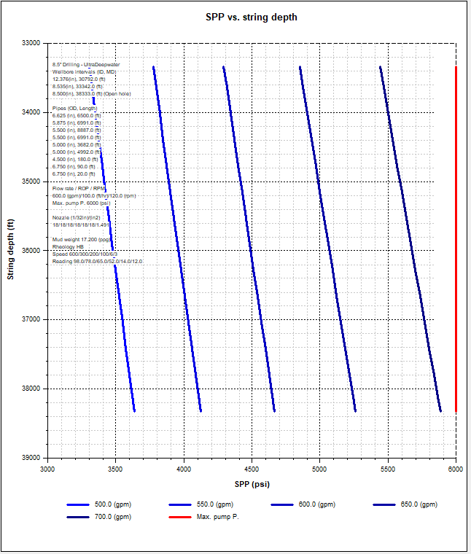

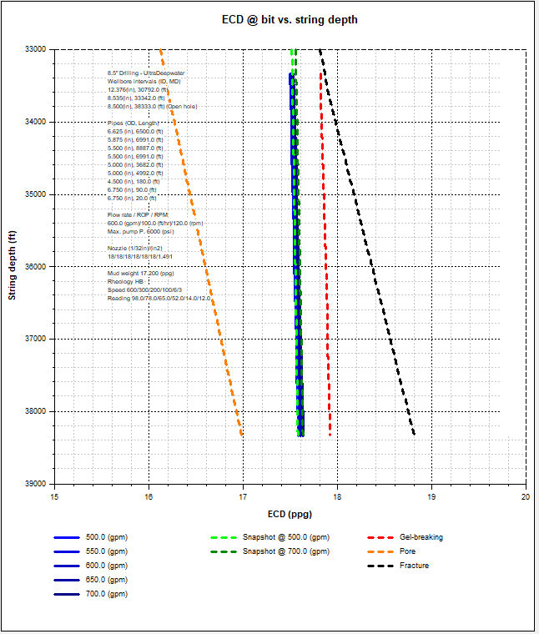

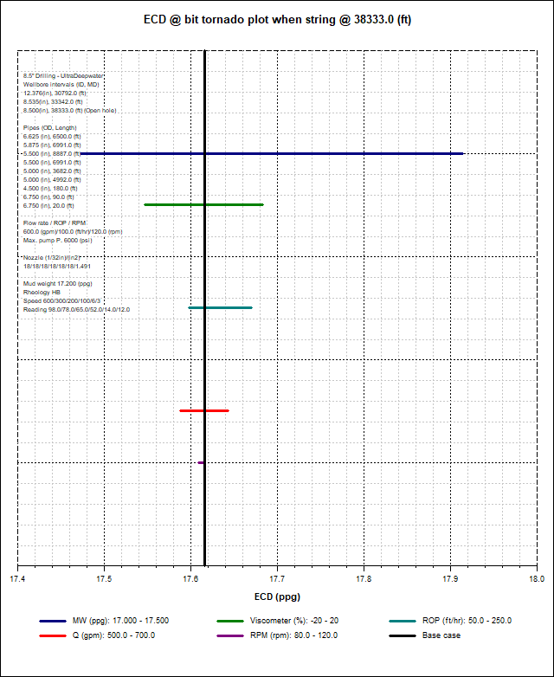

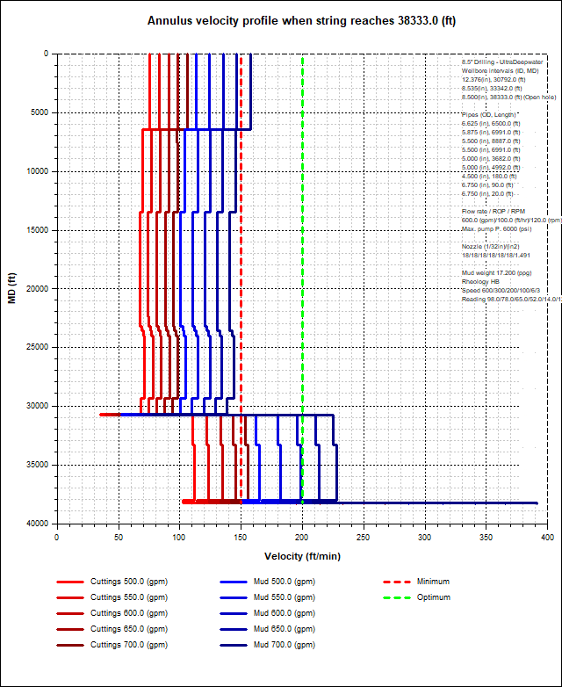

Circulating Sub 7650’ back; Hole requires extra Cleanup Time
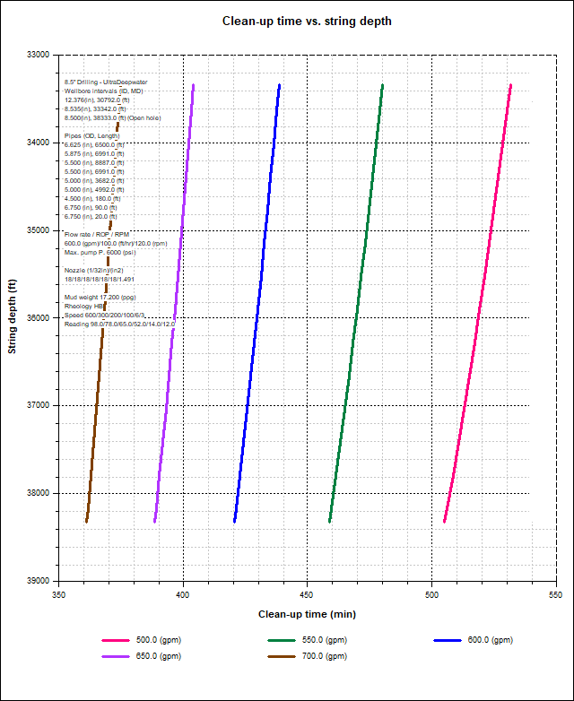

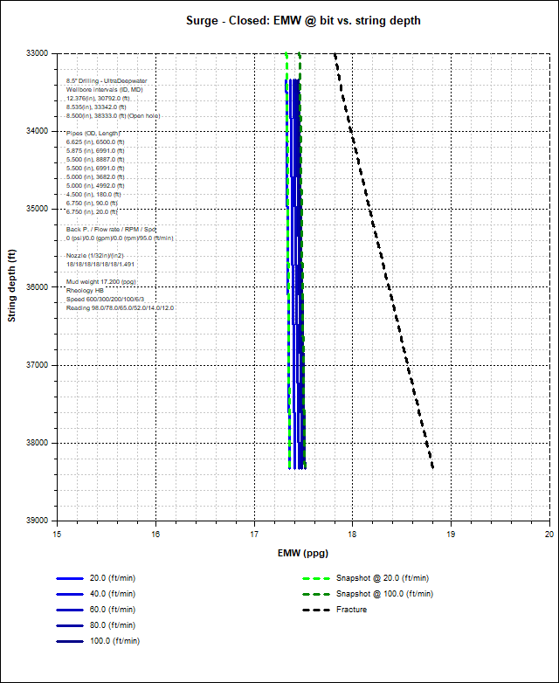

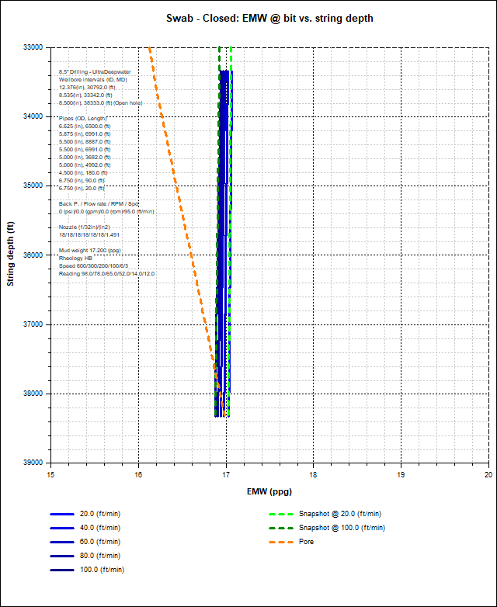

Need to idle pumps when working pipe near-bottom
